MahdiReza Heidari Dastjerdi

university of tehran - ibme  810100273

EEG & ECG amplifier

**ECG amplifying process**

The designed circuit contains modules below:

1. 3 sine voltage generators that add to each other with resistors

* A. sinus signal with amplitude of 5m Vp and frequency of 10hz
* B. sinus signal with amplitude of 2.5m Vp and frequency of 50hz
* C. sinus signal with amplitude of 2.5m Vp and frequency of 1Mhz

1. One operational amplifier to amplify the signals
2. One operational amplifier used as a low pass filter to filter the signals higher than 1 megahertz
3. One operational amplifier used as notch filter to avoid passing of signals in 50hz (city electricity)

Part1: Adding

We simply connect the wires to a final node to add our 3 signals.

Part2: Amplifying the signal

We use a non-inverting amplifier with gain of $1+\left(\frac{Rf}{Ri}\right)$

So if we want out main signal to be amplified 1000 to 5000 times, the Rf/Ri should be around that number, I’ve used a 5 MΩ potentiometer (5M at max and 1 M on 20% load) and 10 kΩ for Ri so the gain should be around 5M(or 1M)/10k = 500 this relation is not equal to neither 1000 or 5000 this is because of the gain of other modules so I calibrates it in a 100 to 500 scale of gain.

Part3: The notch filter

It’s the opposite of band bass filter and we intend to avoid the frequency of 50hz.

Due to the design below, the $fc=\frac{1}{2πRC}$ is 50 hz so I considered the amounts shown below for each module.

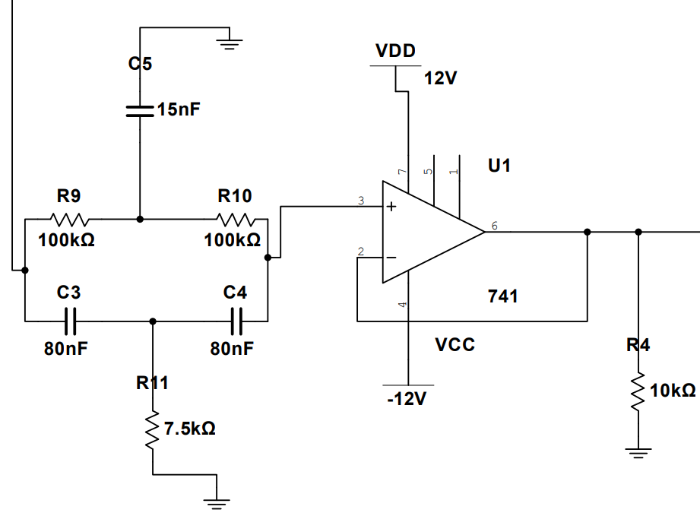

Part4: Low pass filter

The frequency that we intend to filter is 1Mhz, the relation is $fc=\frac{1}{2πRC}$

So by this equation the RC equals 0.0016 so I used a capacitor of 0.3 nF and resistor of 5.3MΩ .

The full design of ECG amplifying circuit is show here:

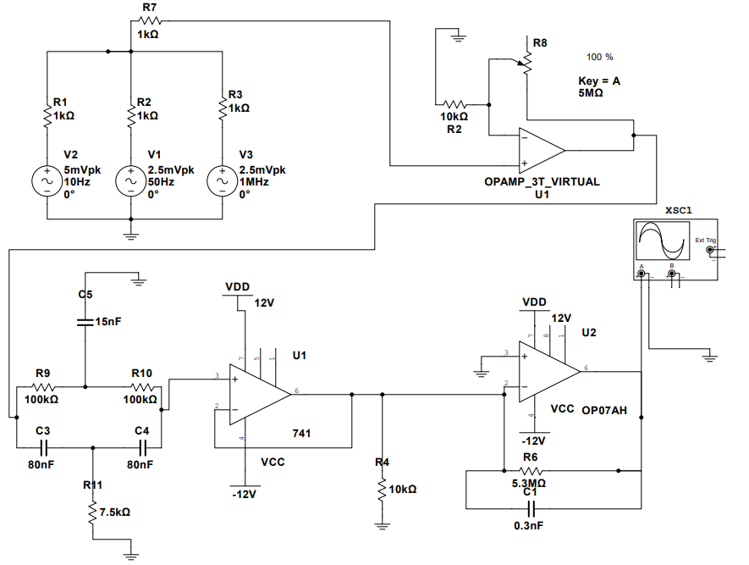

**ECG PLOTTING**

The oscilloscope output was so delayed in time that I couldn’t get a proper plot from it (it resets every 3 block of output display so the waveform is completely corrupted) so I used AC swap to show the frequency filtering. But I show a glimpse of the output voltage to show the final gain.

The plots detail of the figures plotted are written below:

1. The general AC swap of output signal
2. The voltage of signal in frequency of 10hz
3. The notch filter with more resolution to make sure it filters frequencies around 50 hz
4. The oscilloscope output to show the final voltage

The input voltages:

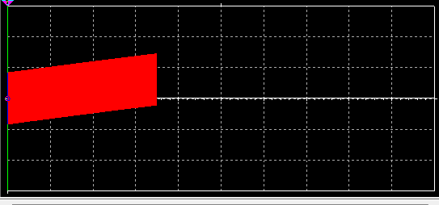 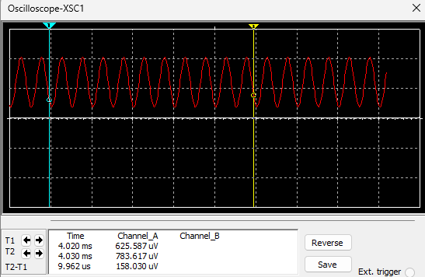

the general signal is shown in the first picture and sinusoidal wave in 1mhz is the noise

By paying attention to the details we come to the conclusion that the wave in moving slowly in the timestamp of 1ms so we can make sure that to general wave is moving up just as a sinus should.

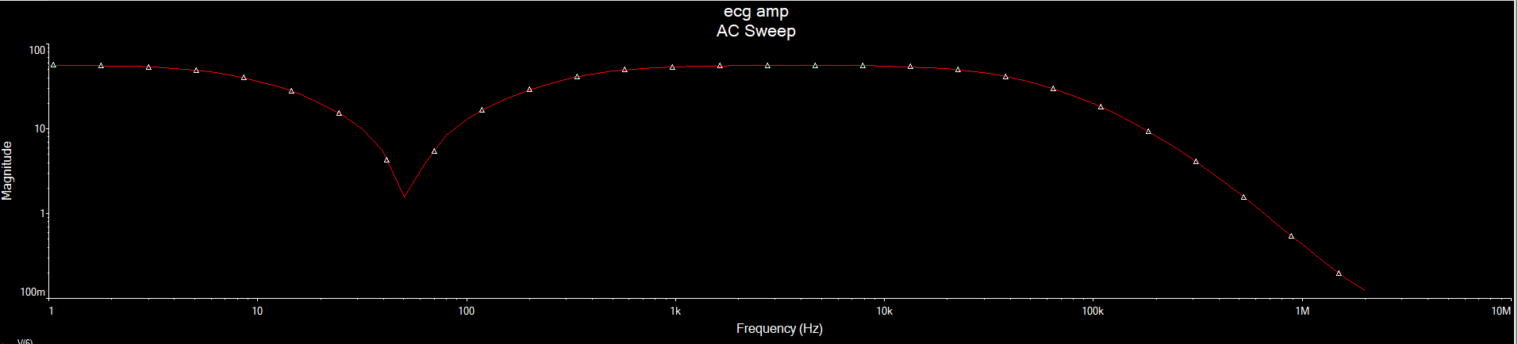

1. As you can see we filter the frequencies of 50hz and more than 1mhz.

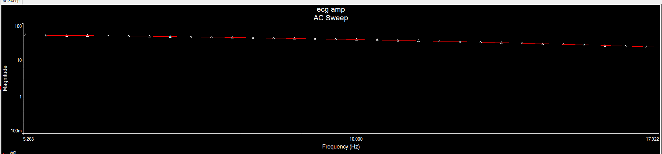

1. This plot shows that in frequency equal to 10hz, the voltage is around 25 volts. So the gain is 25/5millievolts = 5000,

if we put the potentiometer on 20% (1MΩ) the plot will be like: 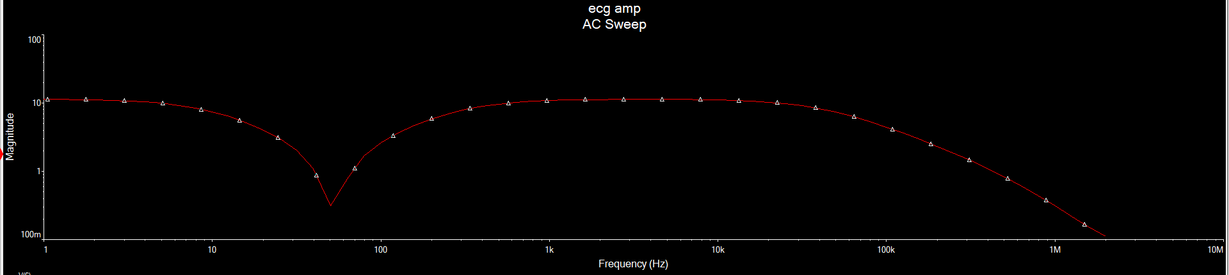

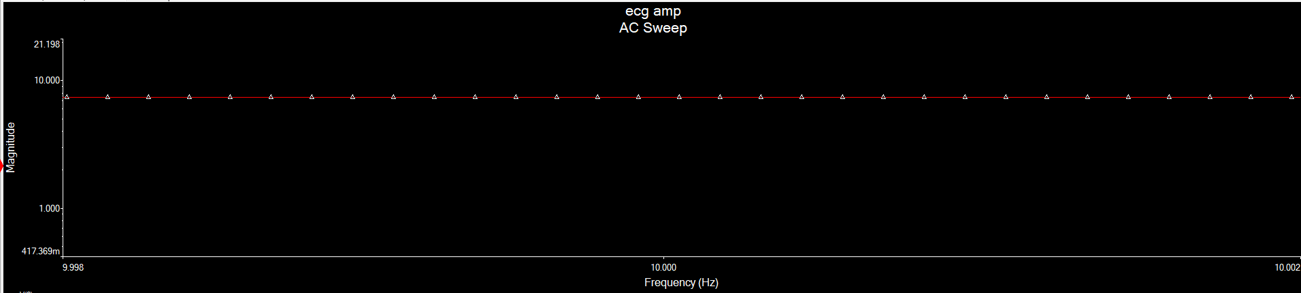

This plot shows that in frequency equal to 10hz, the voltage is around 5-6 volts. So the gain is 5/5millievolts = 1000.

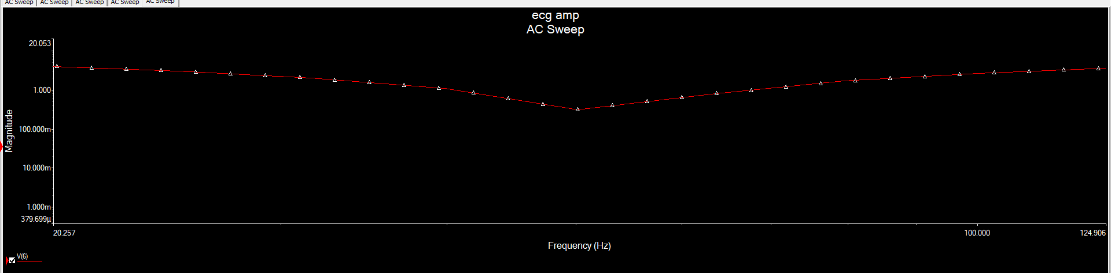

1. The notch filter, filters the 50hz frequency with high precision.

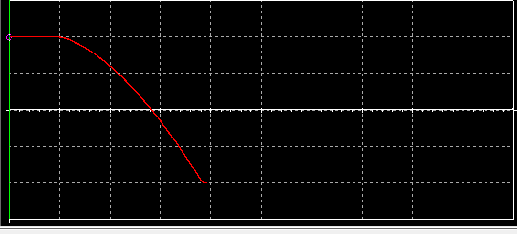

1. This is the output that I get from the oscilloscope.

**EEG amplifying process**

The EEG design is just the same with a few differences discussed below:

* The main signal is lower in frequency (about 15-30hz)
* The main signal is lower in amplitude (so it needs to be amplified more)

So the design which was used is the ECG part works just fine here.

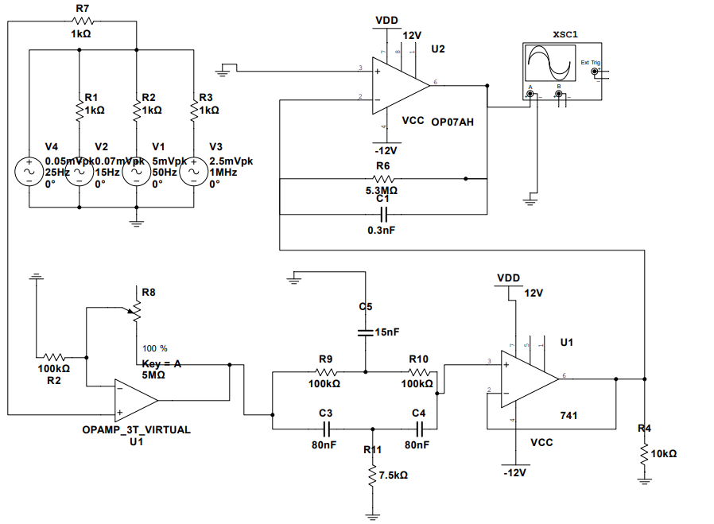

**EEG PLOTTING**

The plotting of EEG signal output is just the same as the ECG PLOTTING so:

The plots detail of the figures plotted are written below:

1. The general AC swap of output signal in range of up to 2M hz
2. The voltage of signal in frequency of 15 to 25 hz.
3. The notch filter with more resolution to make sure it filters frequencies around 50 hz

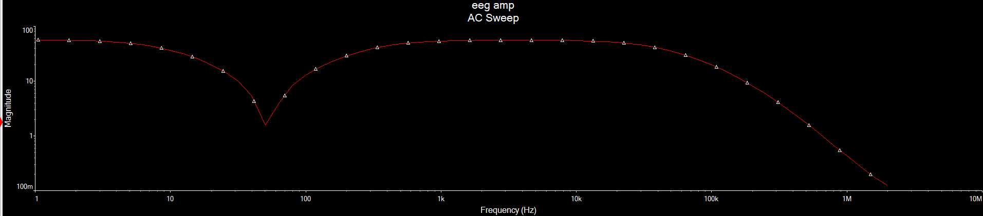

1. As you can see we filter the frequencies of 50hz and more than 1mhz

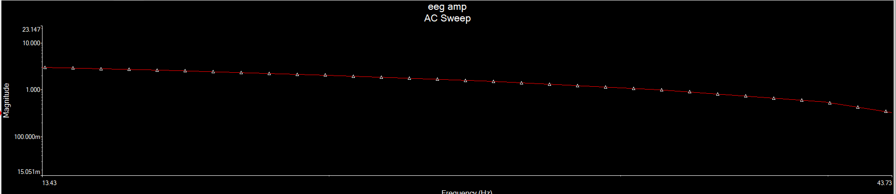 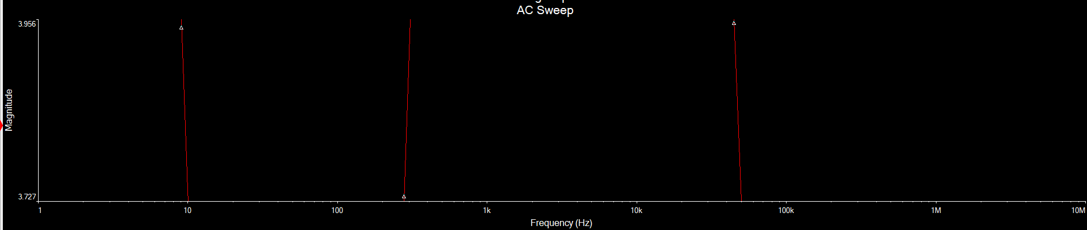

1. The figure above shows that in frequency range of 15 to 25 hz we get about 3 volts on output so the gain is equal to 3volts / 50-70 microvolts, something around 50000 times the input. If we put potentiometer on 20% (1MΩ) the figure will be like: 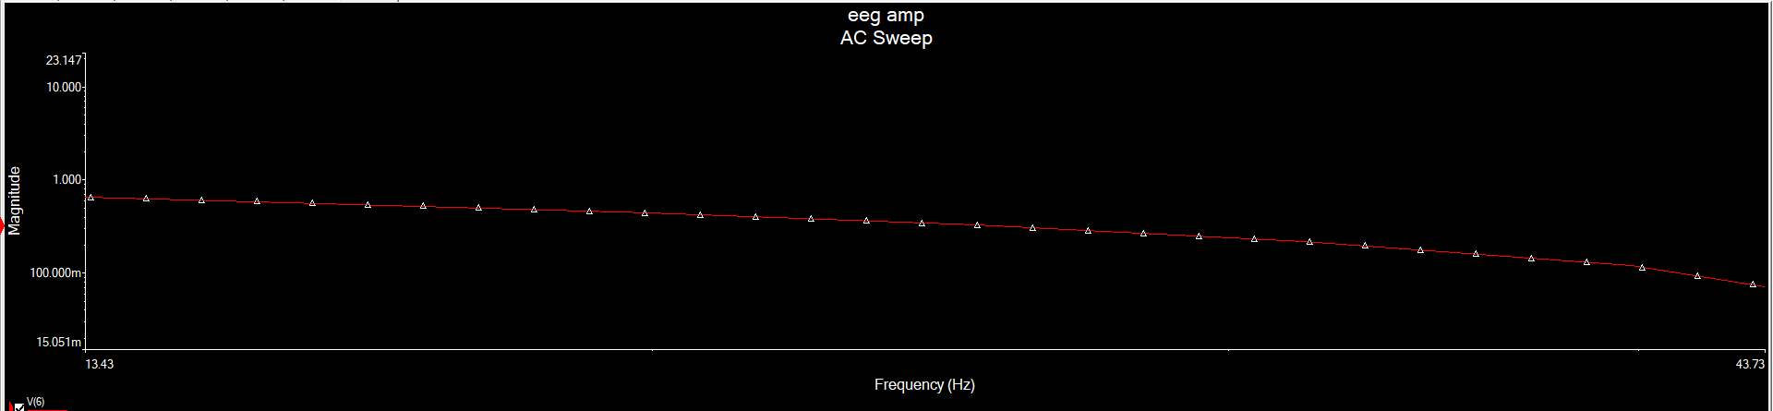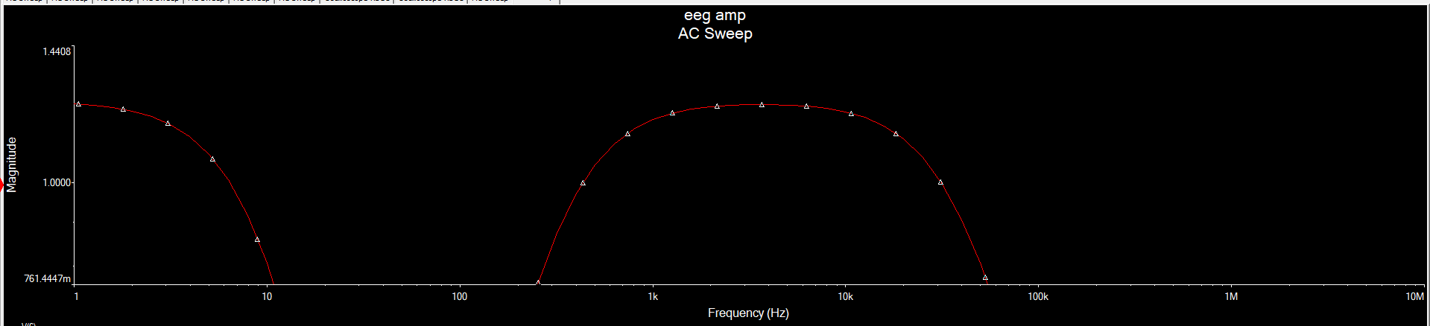

The gain in this case is around 10k (0.3 volts) times the input.

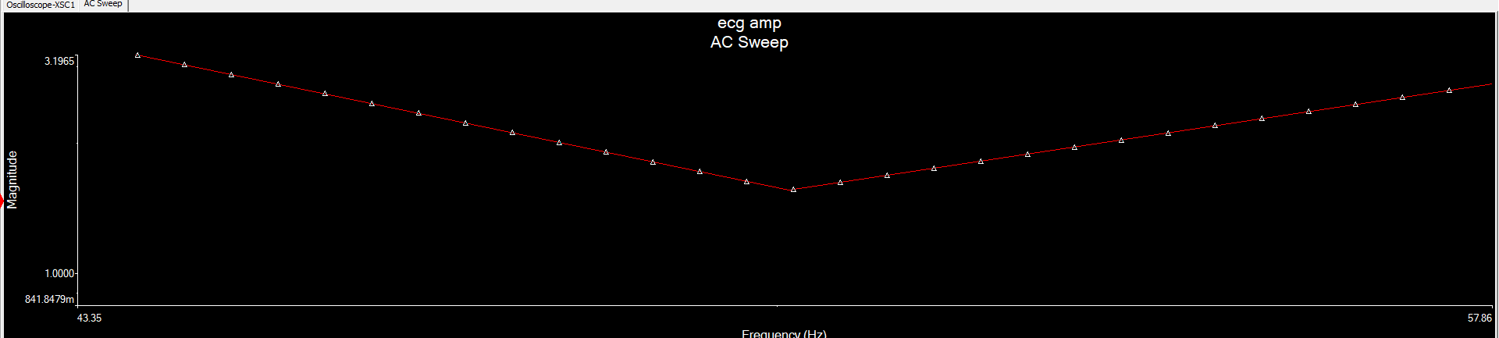

1. The notch filter for EEG signal in 50hz

Note:

The closer we bring out main signal (EEG) to the 50hz (noise of global electricity), the more chane of lowering the magnitude.

The files of multisim designs are uploaded in the zip file of project.